## Dagoberto Flores Sánchez

## Week 2

### 20 august

1. What is *linear* about linear regression?

Linear in linear regression is the approach to modeling the relationship between two variables that follow a pattern predictable.

1. True or false: data which follow a parabolic curve are never modeled properly using linear regression.

False, if you have a parabolic curve, it can be modeled using polynomial equation.

1. Transform the equation 6x +3y-9 =0 into slope/intercept form

6x+3y-9=0

y=(9-6x)/3

for x=0

y= (9)/3

y=3 then….. x=0,y=3 first solution: (0,3)

for y=0

6x-9=0

X=9/6 = 1.5 then… x=1.5 y=0 (1.5,0)

**Solution (0,3) and (1.5,0)**

1. Find the linear eq which contains the points (-2,5) and 3,-1 in the x , y plane.

Y=mx+b

Finding m…. (-1-5)/(3- -2)= -1.2

Y = -1.2x + b

5=-1.2(-2)+b ….. b=2.6 then…

Y=-1.2x+2.6

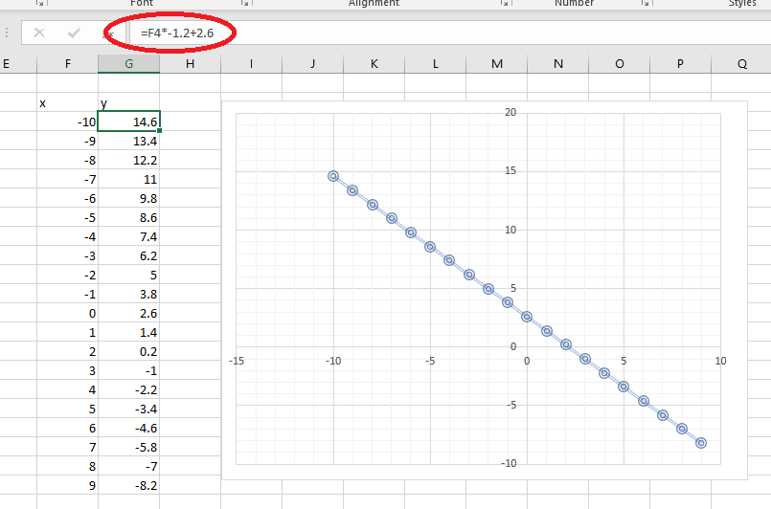

1. What is the difference between regression and correlation?

Correlation is the link between two variables, and regression is the algorithm that describe the behavior of a data set.

1. How many algebraic/geometric dimensions are needed to represent data displaying 5 features?

Two dimensions, one for the identifier of the data , and other for the features.

1. What is the role of the quantity xij in a data matrix?

The role is to count each of the elements of the matrix

1. What is the significance of the quantity ESS Explained Sum of Sqares for a linear regression model?

Tell us how well a model explains the observed data